# **RRP ON AWS:**

# **PRE-REQUISITES:**



# **EXECUTING THE SCRIPTS:**

## **Inside Interface:**

1. Once you login to the RRP instance, you will get a screen like the one below.

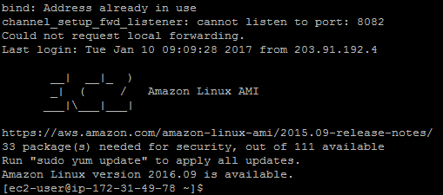

1. Navigate to the path **DemoVersion2 -> python-script -> configuration**. Search for a file named **userConfig.xml**.

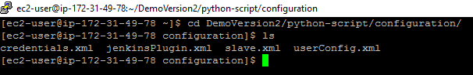

1. Inside the **userConfig.xml**, specify the parameters for e.g. cloudProviderName i.e. AWS or Azure, cloudInstanceCount i.e. 2, 3 or 4 instances, no. of slaves i.e.; 2, 3, 4 etc.

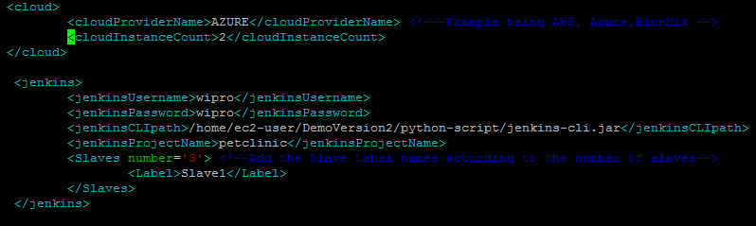

1. Trigger the script **startPython.py**. It will prompt you for the access key, secret key and the location of the private key. Please provide the same.
2. Now, you can see the flow of the script and by the time the script ends, All the instances are created as per the user specifications and with the following names.





1. You can fetch the Public DNS and the Public IP’s of each of the instance by selecting them as shown below.

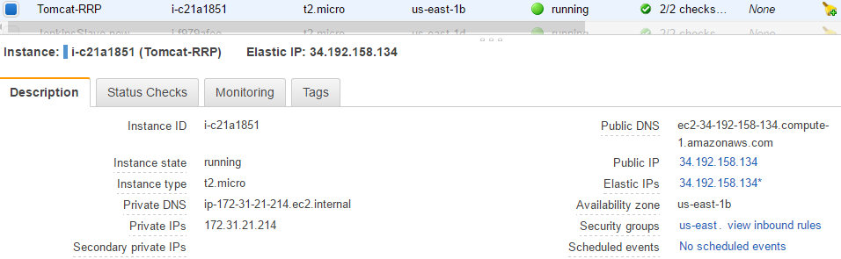

1. You can navigate to each of the site by specifying the Public DNS address followed by **(:8080)**

e.g: ec2-34-192-158-134.compute-1.amazonaws.com:8080

1. It will open the respective applications. E.g: GitBucket/Jenkins/SonarQube/Tomcat etc. based on user specifications. i.e; Single Instance or Multiple Instance.

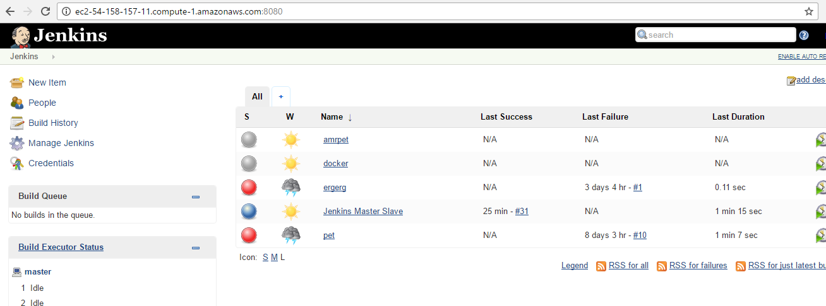

1. Trigger the script **createPipeline.py** from the same path. This will trigger a pipeline job in Jenkins. On completion, it will generate the stage view as shown.

